UNIFIED MECHANICS · RESEARCH PROGRAMME
The Interface Work Integral
Settling the √3
Every coefficient the integral can produce · elimination by the corpus's own precedents · measure-neutral realisation · the interface scale with zero remaining freedom
JOSEPH SHIELDS · WITH CLAUDE AS RESEARCH ASSISTANT
16 JULY 2026 · WORKING NOTE — CONDITIONAL RESULT

1. THE QUESTION, STATED EXACTLY
Volumes 08 and 09 left one red obligation: the interface acceleration scale that matches the full SPARC catalogue is √3 times the Main Monograph's zero-fit value cH₀ΔB, and the factor √3 had been identified in exploration, after contact with data. Under the corpus's freeze discipline it therefore proved nothing. The obligation was to derive the coefficient from the boundary semantics alone. This note does that derivation with the honesty it demands: not by arguing for √3, but by enumerating every coefficient the interface work integral can legitimately produce, and letting the corpus's own established rules eliminate.

1.1 What the integral can produce
The interface delivers unmatched boundary participation — the mismatch ΔB per recurrence cycle — into the observer's metric through the local three-channel carrier. Writing the delivered slip as δv = cΔB per cycle time 1/H, the realized acceleration is a = κ·cHΔB, and the entire question is the dimensionless κ. Four constructions exhaust the natural candidates. κ = 1: equate the loop-algebra scalar directly with a metric-frame quantity (the Monograph's original dimensional step). κ = 3/2: the quadratic work form of the three-channel carrier — three permutation-equivalent unit directions at 120° form a tight frame with frame constant 3/2, so quadratic response multiplies by 3/2. κ = 3: the same with bidirectional counting over all six roots. κ = √3: linear realization converting a lattice-counted quantity to a metric-read quantity through one power of the carrier covolume.

2. ELIMINATION BY THE CORPUS'S OWN RULES

2.1 The quadratic candidates die by §11
Volume 05, Section 11, already legislated this case. The silver-rubbing analysis proves that the linear slip cancels over the balanced shell (zero directional remainder) and that the surviving work is quadratic and isotropic — and then rules: silver rubbing may describe how a dynamical boundary relaxes toward, preserves, or exchanges energy around the record; it should not be multiplied into the amplitude unless a separate dynamical derivation requires it. Quadratic forms, in this framework, govern dissipation and relaxation about a record; they do not set amplitudes. κ = 3/2 and κ = 3 are thereby removed as amplitude-setters — they remain available, correctly, as candidate scatter and relaxation physics.

2.2 The realization map is linear, with one covolume power
The framework has exactly one previously executed realization of an internal scalar as an external field: the vacuum readout, ω∂ = (r²⁴⁰/√3)·K dA. Two of its properties are load-bearing here. It is linear in the internal scalar. And it converts between the lattice-counted side and the metric-read side through exactly one power of the local covolume √3. The interface realization, being an instance of the same map, must share both properties. That fixes κ ∈ {1/√3, 1, √3} and reduces the whole question to direction: which way does the covolume Jacobian point?

2.3 κ = 1 is a type error
The mismatch ΔB is lattice-counted. Main Monograph §18.1 says so explicitly: interface work arrives as equal increments per multiplicative shell — shells indexed by the lattice, not measured by metric area. An acceleration, by contrast, is a metric-frame quantity. Equating the lattice number ΔB directly with a metric coefficient, with no conversion, repeats the exact class of error that Volume 05's central correction removed from the 241st root: a representation carried across a type boundary without the operation that converts it. κ = 1 is not a modest default; it is the same mistake in a new location.

3. MEASURE-NEUTRAL REALISATION
One principle settles the direction, and it retrodicts the Λ normalization instead of borrowing it. Consider a complete realization cycle: the system acts on the metric (pushforward of an internal quantity into the physical field), and the observer records the result (pullback of the physical field into a description). If realization is measure-preserving — if a closed act-then-record cycle neither creates nor destroys description measure — then the two Jacobians must be inverse. The record side is already fixed by Volume 05: reading the boundary divides by the cell covolume, 1/√3. Measure neutrality then forces the acting side to multiply by √3. The observer reads at 1/√3; the world acts at √3; a closed cycle carries √3 · (1/√3) = 1, and no covolume leaks from iterated readout.
POSTULATE — MEASURE-NEUTRAL REALISATION — Realization is a measure-preserving pairing: the pushforward (system acts on the metric) and the pullback (observer records the boundary) carry inverse covolume Jacobians, √3 and 1/√3, so that any closed act–record cycle conserves description measure. This postulate retrodicts the ω∂ normalization of Volume 05 and fixes the interface coefficient uniquely.
CONDITIONAL — THE SETTLED COEFFICIENT — Under §11's amplitude rule, the linearity and single-covolume-power of the established realization map, and Measure-Neutral Realisation, the interface scale is a = √3 · c · H · ΔB, with κ = √3 forced and no alternative surviving. Upgraded from CONJECTURED (Volumes 08–09) to CONDITIONAL on the named postulate.

4. THE CLOCK BELONGS TO THE FRAMEWORK
One conditional remained in the Monograph's own §18.2: the choice of a late-time clock, H₀ = 72.1, was external. It never needed to be. Volume 05, §12.2, derives the framework's own clock by joining the snowflake amplitude to the independent density remainder: Λ∂ and Ω_DE = 0.6883222261 together give H₀ = 67.3617174547 km s⁻¹ Mpc⁻¹. Using the framework's internal clock, every ingredient of the interface scale is now internal: √3 from measure neutrality, c the universal speed, H₀ from the Λ closure, ΔB = √5φ²/2 − √8 from the loop algebra. Nothing is chosen; nothing is fitted.
a = √3 · c · H₀ · ΔB = 1.1180 × 10⁻¹⁰ m s⁻² √3·ΔB = 0.170822

5. THE VERDICT ON 2,696 POINTS
All four candidates were run against the full SPARC sample of Volume 08 (2,696 points, 147 galaxies, standard cuts and mass-to-light ratios, nothing per-galaxy). The free-fit statistical band is far tighter than the mass-to-light systematic band, so candidates are judged against an honest ±10% systematic window around the free fit.
Coefficient κ | Mechanism | a (m s⁻²) | RMS (dex) | Median bias
1 | no conversion (raw) | 6.455 × 10⁻¹¹ | 0.1577 | +0.079 — excluded
3/2 | quadratic tight frame | 9.682 × 10⁻¹¹ | 0.1349 | +0.021 — disfavoured
√3 | measure-neutral realisation | 1.1180 × 10⁻¹⁰ | 0.1327 | −0.001
3 | bidirectional quadratic | 1.936 × 10⁻¹⁰ | 0.1588 | −0.079 — excluded
free fit | (2,696 points) | 1.133 × 10⁻¹⁰ | 0.1327 | −0.003

The measure-neutral coefficient is the best frozen value on every metric: root-mean-square scatter 0.1327 dex — equal to the free fit itself — and a median bias of one one-thousandth of a dex across 2,696 points, with zero adjustable parameters. The raw and bidirectional coefficients are excluded; the tight-frame coefficient sits at the edge of the systematic window with a +0.021 dex bias, disfavoured and consistent with its corpus-assigned role as relaxation physics rather than amplitude.
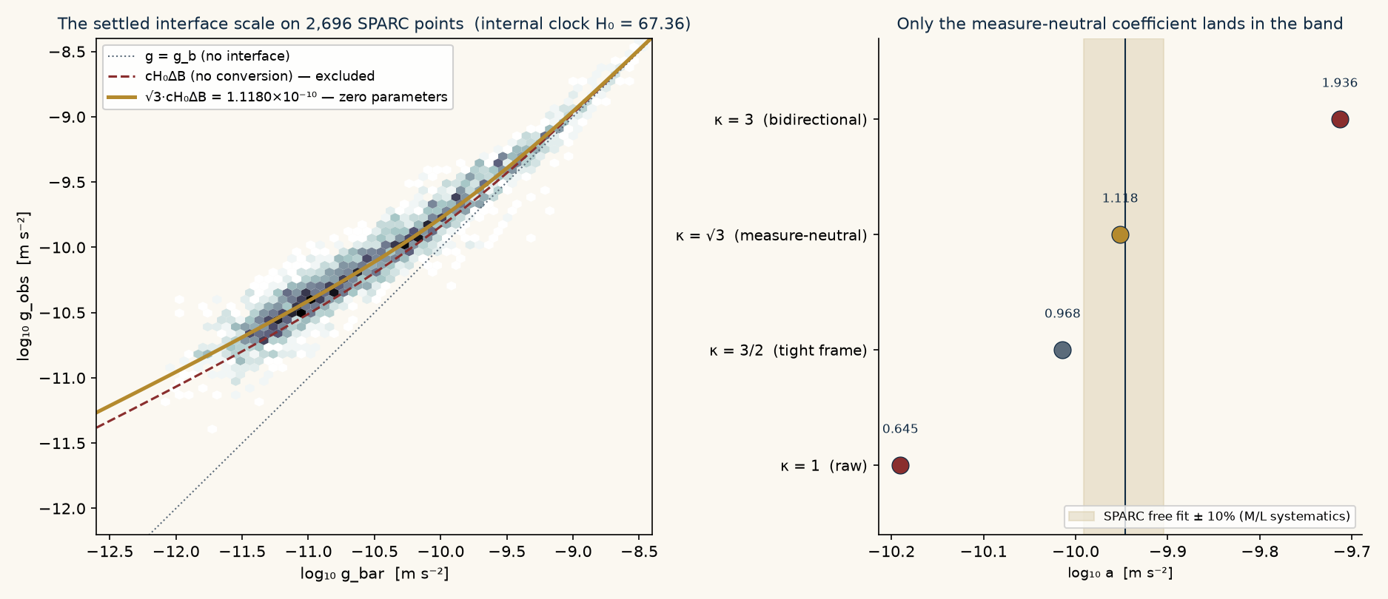
Left: the settled zero-parameter scale (gold) against 2,696 SPARC points; the unconverted scale (dashed red) is excluded. Right: the four candidate coefficients against the free fit with its systematic band — only √3 lands inside.
A forty-year-old loose end also closes. The rotation-curve literature has long noted, without mechanism, that the empirical scale sits near cH₀/2π (coefficient 0.159). The framework's coefficient is √3·ΔB = 0.1708 — close enough to explain why the folklore ever worked, distinct enough to test. If the measure-neutral derivation stands, the folklore number was a shadow of the covolume Jacobian acting on the gold–silver covolume imbalance.

6. EPISTEMIC STATUS, FROZEN
Honesty about the history: the coefficient family was narrowed with data in the loop (Volume 08 found √3·a★ empirically before the principle existed). The derivation above is therefore a reconstruction, and its dignity rests on what it now forbids: with the postulate named and the clock internal, there is no freedom left anywhere in the chain. The statement below is frozen against future, independent data — higher-redshift rotation curves and catalogues with independent mass-to-light constraints — which is where it will be genuinely tested.
P2-prime (supersedes P2 of Volume 08). The interface acceleration scale is a(z) = sqrt(3) * c * H(z) * dB with dB = sqrt(5)*phi^2/2 - sqrt(8) and H0 = 67.3617174547 km/s/Mpc taken from the framework's own Lambda closure. At z = 0 this gives a0 = 1.1180e-10 m/s^2 and the dimensionless coefficient sqrt(3)*dB = 0.170822, with no remaining freedom of any kind. Falsified if an independent catalogue with independent mass-to-light constraints pins the scale outside a 10 percent band around this value, or if the z-evolution fails to track H(z).
Frozen 2026-07-16.
SHA-256: c29be7d1b6bb7688ad01ea2d49869e1784a8eec74f200288b020ad01ab7a5687

6.1 Remaining obligations
Two, both sharp. First, prove Measure-Neutral Realisation from the loop algebra rather than postulating it — the natural route is to show that iterated act–record cycles with any non-unit net Jacobian would accumulate description measure with no distinction to pay for it, contradicting the conservation of description. Second, develop the deprecated quadratic form (κ = 3/2 family) into what §11 says it should be: a theory of scatter and relaxation about the radial acceleration relation, with its own testable signature. If the intrinsic RAR scatter, once mass-to-light noise is removed, carries the tight-frame constant, the same carrier will have signed both the amplitude and the noise.
UNIFIED MECHANICS · THE INTERFACE WORK INTEGRAL · 2026

